Progress Report

Welfare Association Jared
  - Village & PO Jared Tehsil Balakot
  - District Mansehra
Cell: +92+344+9445476
Website: www.waj.org.pk
Mail: info@waj.org.pk

Key Achievements

Key Achievement of Welfare Association Jared

- Flood Relief 1992-1993:
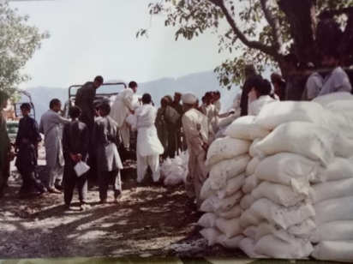
Soon after the devastating flood in 1992, Welfare Association Jared started relief activities in Kaghan, Jared Mohandri, Kaiwai Union Councils of Kaghan valley and provided the flood affectees with tent, blankets, utensil, daily food items and cash grants donated by Sungi Development Foundation, Zia Shaheed organization Lahore and various philanthropists.
- Rehabilitation work 1993-2005:
Ration distribution Flood 1992 affectees Jared
After immediate relief work WAJ entered into rehabilitation work of affected areas and provided the affectees with following Community Productive Infrastructure (CPI) schemes;
- Water channles in UC Kaghan and Jared Mohandi

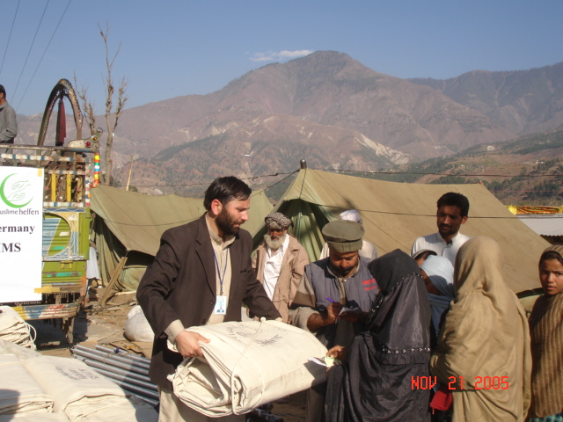
- Water supply schemes in UC Kagahn and Jared Mohandi

- Small foot bridges in UC Kaghan

- Small footpaths in UC Jared Mohandri

- Safety wall in UC Jared Mohandri
Muslim Helfen in Balakot

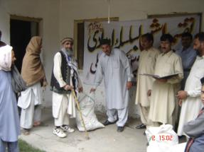
- Forestry sector reforms 1993-1997:
WAJ with the close collaboration of Sungi Development Foundation started advocacy campaign on the protection of forest in Hazara and Upper Dir . In year 1993, WAJ arranged public hearings in Jared, Mohadri, Manoor Valley and Kaghan where all stakeholders including forest owners, tenets, forest department, media and multiple donor community were invited.
Ration distribution snow fall affectees 2004 Naran
As a result of advocacy campaign forestry sectors reforms were introduced in KPK (former NWFP). Forest cooperative society were banned in 1993 and Joint Forest Management Committees (JFMC) were formed under the law. Due to this effort illicit cutting of forest were stopped since 1993

- Social Organization:
After rehabilitation work WAJ started organizing people of 22 localities into men and women village organization (VO) under the umbrella of WAJ. The VO were trained inn community Management and Leadership Skills (CMST), Leadership & Management Skills (LMST), Gender, record keeping, operation & Maintenance of completed projects and policy advocacy.

- Small loan Trickle up grants to widows 1993-1997:
WAJ with the assistance of Trickle-up program started small grants program with the assistance of trickle up program and provided 20 widow of UC Jared Mohandri with small to start their livelihood. Women purchased sewing machines and goats to start their business. The program beard good results uplift the living condition of widows.

- Role of WAJ in Social Service delivery 1993-1997:
WAJ played key role in the provision of health and education service to the marginalized community of Kaghan Valley since its inception. Following are the key achievement;
Health
- Due to WAJ efforts Government Higher Secondary School (GHSS) was established in UC Mohandri, first ever in Kaghan valley in 1994-95

- WAJ supported District Health Department Mansehra start National Health Program in Kaghan Valley.

- Identified and trained 20 Lady Health Workers in spite of resistance from local religious circles. They are now doing their services in rural areas of valley

- Due to WAJ local advocacy campaign, qualified MBBS Doctor and Technician were appointed in BHU Jared

- WAJ kept vigilant eye on the provision of free medicines in BHU

- WAJ provided 20 demo-latrines in various localities motivate the community establish latrines in their home

- WAJ also played role in the establishment of “Civil Dispensaries” in far flung localities of Nakian and Buttan UC Jared Mohandi

- Played key role in the reconstruction of BHU Jared and nearby localities infrastructures
Education
- WAJ played key role in the establishment of first Government Girls High School (GGHS) in Jared in 1994-95

- WAJ encouraged locals to start 2 public schools in UC raise the standard of education in the valley

- WAJ provided poor students of all 22 localities with school fee, books and uniform free of cost

- Established free tuition center for higher classes poor students

- Started campaign against “Naqal Mafia” to raise the standard of education

Natural Resource Management (NRM)
- Local farmers were given training about;

  - off seasonal vegetables

  - Orchid management

  - Preservation of local seeds on modern scientific lines by establish seed banks

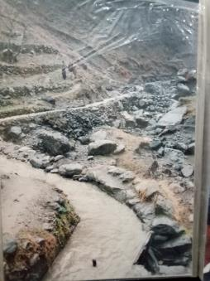
  - Tea demo plots

  - Nurseries raising

  - Block plantation of broad leaves species

- Provided support to Sungi and Third Vision International (TVI) in preparing documentaries: “Vanishing Shadows and ”before its late”

Disasters Management
  - Trained 200 activists on disaster management
Water Channlel Ochri Buttan

  - Provided toolkits to the trained activists

  - Supported flood affectees in 1992 devastating flood

  - During the earthquake 2003 WAJ Provided twenty families with Rs.24000/affectees for the construction/repairing of their damaged house

  - WAJ distributed food packages among affectees of 2004 heavy snow fall in whole Kaghan Valley

  - Supported earthquake affectees in rescue from damaged UCs of Valley to Mansehra and Abbottabad and Rawalpindi civil and military hospitals through Halley service
  - Provided support to the community of valley in rehabilitation and reconstructions of schools, hospital, water channels, drinking water supply schemes,

  - Provided shelter, food and non-food items to the affectees of earthquake 2005 in whole valley

Civic Education
  - Identified and trained 50 civic rights activists men and women

  - Engaged them in forestry campaign

  - The activists started campaign on the rights of affectees of “Farm to Market

  - Road” constructed with the assistance of ADB from Balakot to Hangrai

Micro-Finance
  - Provided loan facilities to poor men and women loansees from 1995-2003

  - WAJ started microfinance for 27 poor people in 2015 that is on-going

- Skills Center for Women
With the assistance of Social welfare Department KPK WAJ constructed its own Community Center in Jared. Land was provided by the then resident of WAJ fee of cost. Social Welfare department provided some sewing and knitting machines to WAJ. WAJ started skill development program for women of Kaghan Valley for 10-year but unfortunately due to heavy earthquake the community center and the equipment were lost.

- Role of WAJ in promoting social accountability
WAJ is well known for the efforts of its young social activists to promote and protect rights of marginalized especially for women and low class community. WAJ started political awareness raising campaign during the election of 1988, 1990, 1992, 1996, 1998, 2002, 2005, 2008 and 2013. WAJ was successful enough in following landmarks;

- Half century old mindset of the community changed and they started campaign in favor of new political leaders to get rid of traditional politicians

- WAJ motivated women to cast their vote first time in the history of valley during the election 2005

- WAJ rejected local Jirga system and established an alternated dispute resolution system run by young activists

- The decisions made by these activists were on merit and thus the polarity of WAJ raised day by day. People supported the activists’ thus defeated and boycotted influential and gender-blind Jirga system.

- WAJ controlled Jared Bazar rates by doing “Test Purchase”

- Started campaign against corrupt officials in Education, health, Police and land revenue though their departmental policies and procedures

- During the election 1998 WAJ with the collaboration of Sungi and Aurat Foundation started campaign “Roles and Responsibilities of Citizens in Election 1998”

- Arranged public forum with the support of Sap-PK on “Democracy and people Empowerment”

- WAJ started campaign against the then chairman local council and corrupt contactors and started enquires on many public schemes that were only in papers.

Problems Faced:
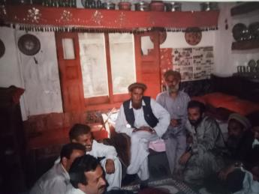
WAJ was given very tough tome by local timber mafia headed by local MPA. They pressurized office bearer of WAJ when they arranged a Public Hearing “ Janglat aour Ham” in UC Jared in 1993. MPA utilized local police and h arrested president WAJ but with the support of local community WAJ was successful arranging this hearing where the then general Secretary of WAJ gave idea of “Green Triangle” to save the forest by involving three key stakeholders- The Community, Forest Department and The Administration. The idea was appreciated by the participants of public hearing including foreign donors, national and international media and notables.
SNI Meeting with Jared Community

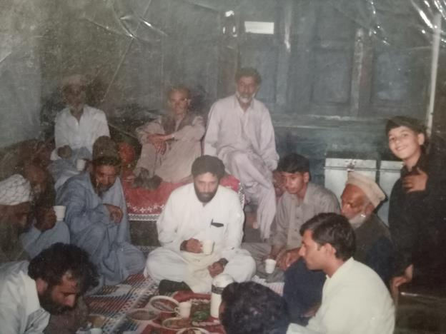
Second wave of resistance started against WAJ when they started political education in 2005. Local politicians and religious clergy started propaganda against WAJ and (late) Omar Asghar Khan Founding Sungi. District Khateeb and administration spared no efforts pressurizing WAJ stop women casting their votes but WAJ youngsters remained form footed and loya to their commitment and women nt only casted their votes but also contested and 7 women the LG election first time in the history of valley.

Omar Asghar Khan with Jared Community
WAJ broken local Power Structure in valley
WAJ was successful broken the “Power Structure” in the valley. Results of the election were totally in favor of marginalized in general as well as Local Government election. At this defeat “Local Influential” hatched conspiracy against WAJ and Sungi and they malhandled (late) Omar Asghar Khan in Jared Bazar but with the substantial support of locals the culprits were arrested and put behind the bar. With the efforts of Sahrad NGOs Ittehad (SNI), Omar Asghar Khan and WAJ took back the case from the court in the best interest of community.

